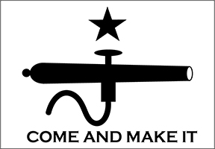



SCALE: 1/

MANUFACTURER:

Please describe any details, finishes, or features of special note regarding the construction of this model. You may attach additional sheets if needed.

Description of Work Performed

Fold this section under and place form with your entry

By entering the National Contest, I agree to abide by the rules set forth by the IPMS/USA National Contest Committee.

Name

State

City

Country

IMEF Version 2.2

**Individual Model**

**Entry Form**

2023 IPMS/USA

National Convention San Marcos, Texas

IPMS Number + Entry Number

(Example: 12345678-1)

Category Number

Theme Awards - Check box if your entry is eligible

A. Six Flags Over Texas: Spain

Place Special Category/Theme

Award Labels Here (Staff Only)

B. Six Flags Over Texas: France

C. Six Flags Over Texas: Mexico

D. Six Flags Over Texas: Republic of Texas

E. Six Flags Over Texas: Confederate States of America

Photographers Marks

(Staff Only)

F. Six Flags Over Texas: United State of America

G. Best Use Of Convention Decals

SUBJECT: